| Course Name | ITD 2313 – Script Programming |
| --- | --- |
| Instructor | Mark Pranger |
| Student Name | Weston Albright |
| Due date | 05/27/2025 |
| Grade | 99.02% |
| Grading Comments | N/A |

Page 54

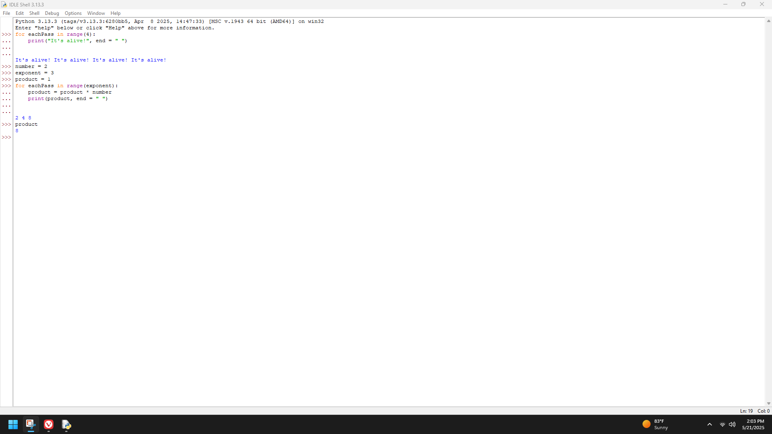

Page 55

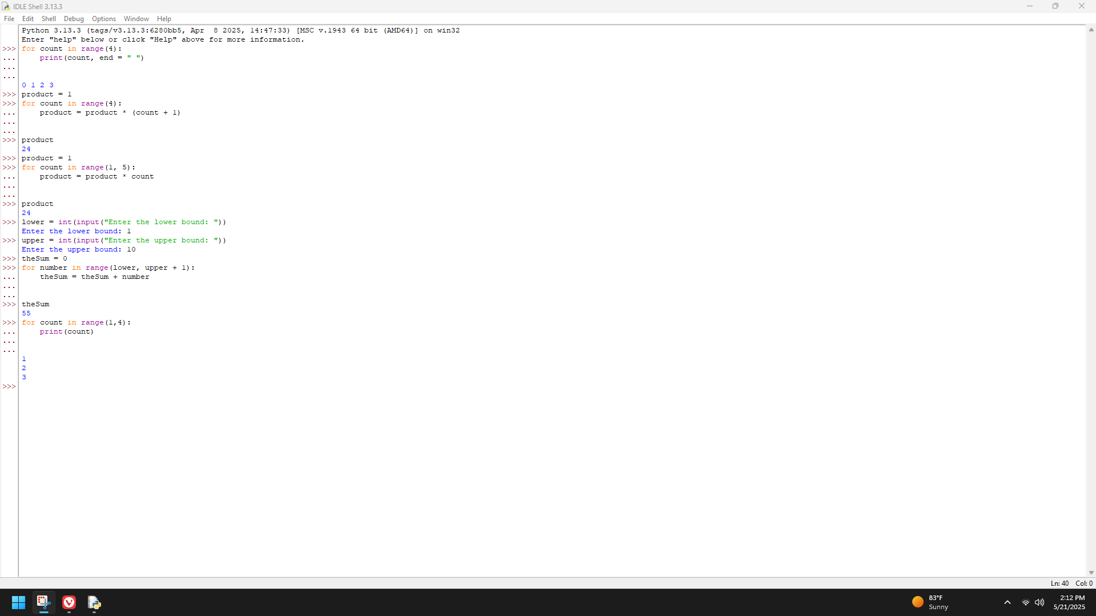

Page 57

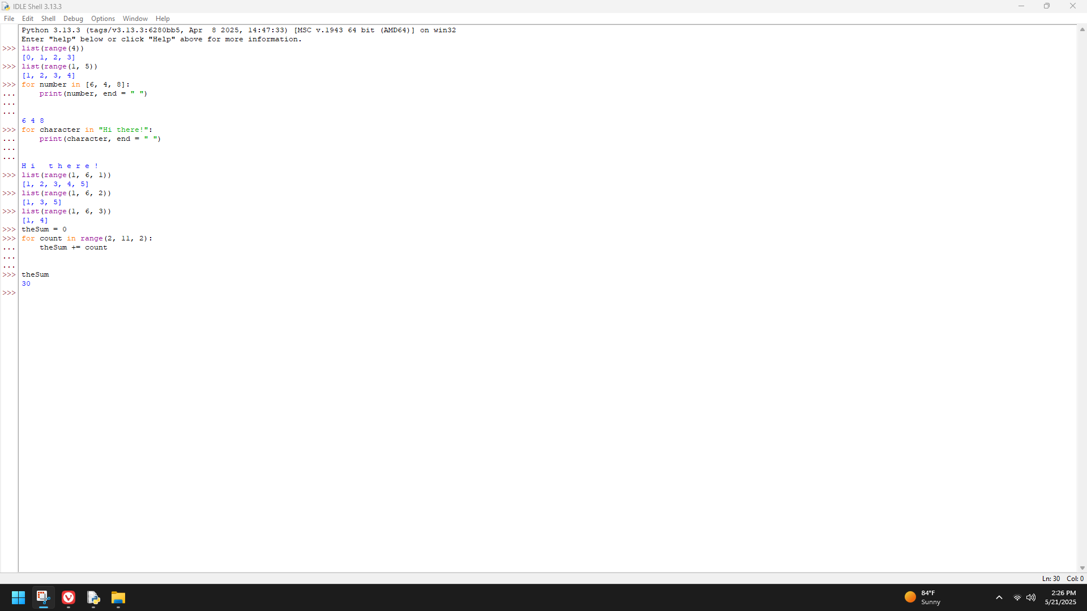

Page 58

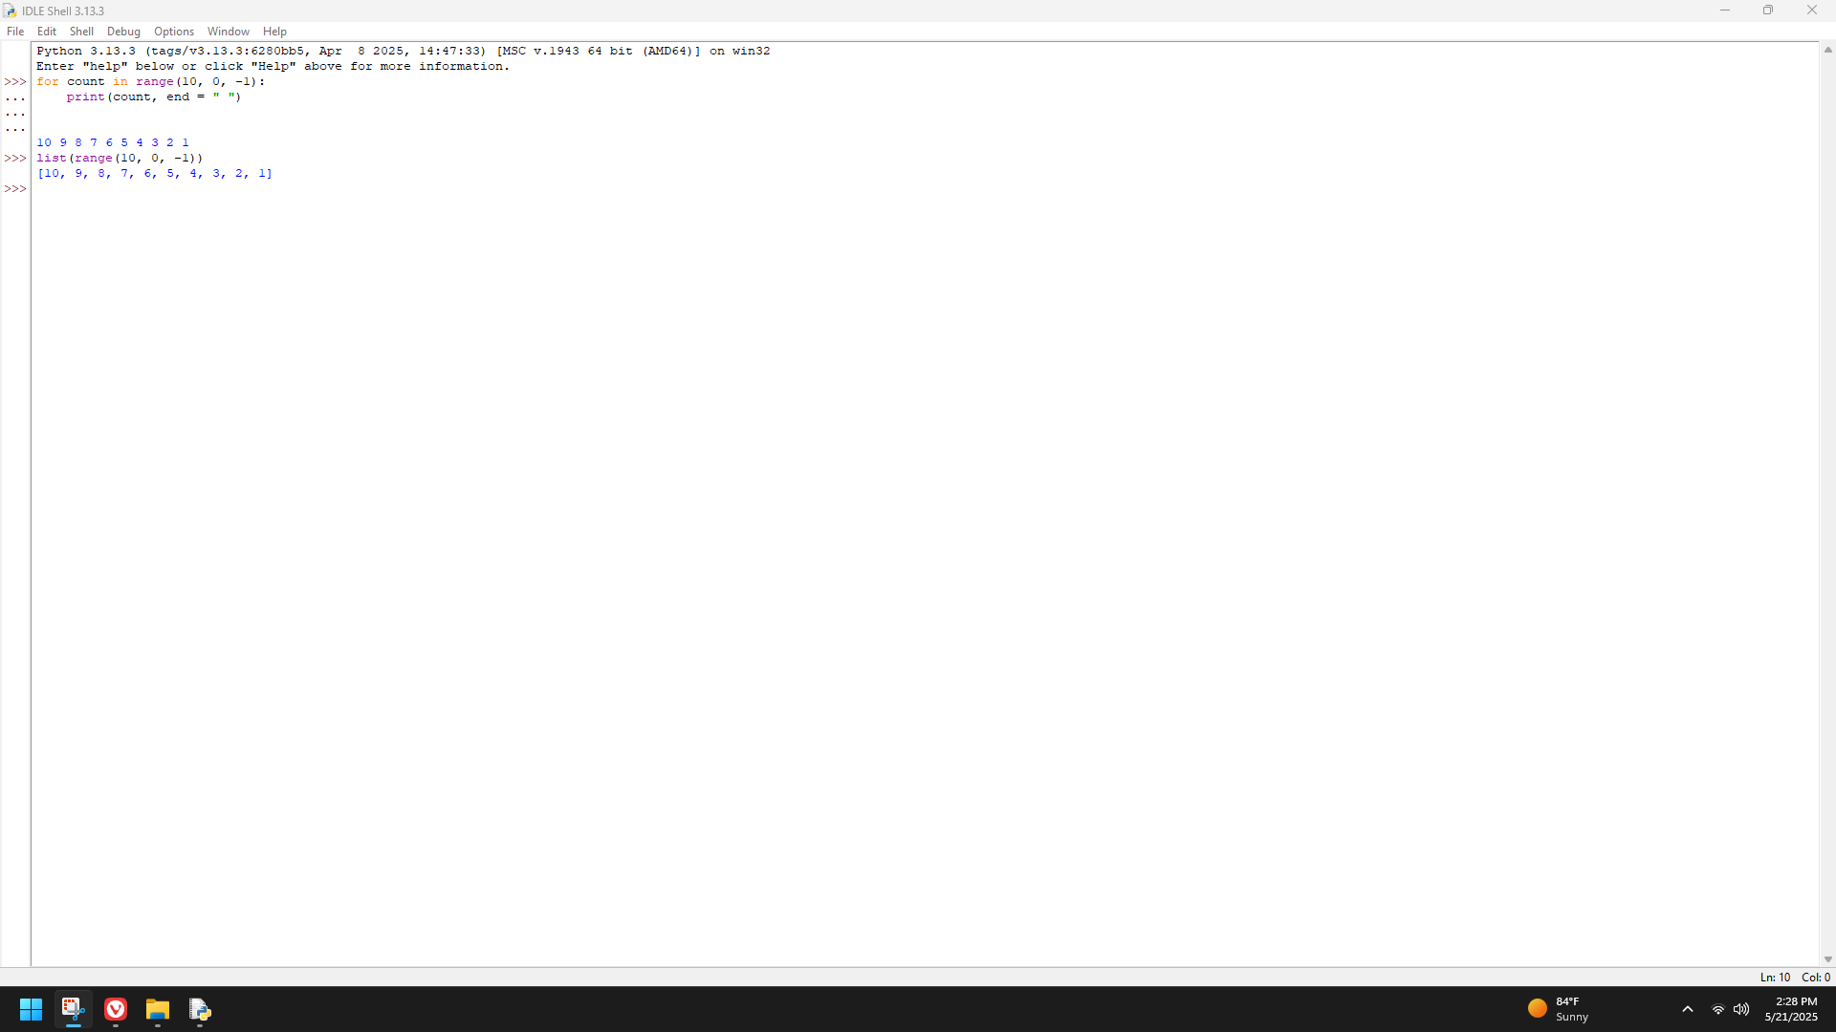

Page 59

